**Case Study**

**Profile of M/s Surya Industries**

|  |  |
| --- | --- |
| **Name of the Enterprise** | M/s Surya Industries |
| **Udyog Aadhaar/SSI Registration No.** | 280041201467 |
| **GST** | 36BLOPD1178C1ZA |
| **Line of activity** | Manufacturing of PVC Pipes and Sheets PP & PVC, Spiral wire folders and Book Binding Products |
| **Factory Address** | Plot No: 26/A, Phase – IV, IP, Pashamylaram, Patancheru Mandal, Sangareddy District |
| **Registered office Address** | Plot No: 26/A, Phase – IV, IP, Pashamylaram, Patancheru Mandal, Sangareddy District |
| **Establishment year** | 2013 |
| **Constitution** | Sole Proprietor |
| **Details of Partners / Directors / Proprietor and their age** | Mrs. D. Jyothi - 45 |
| **Primary Lender** | APSFC |

**Brief History and Problems encountered by the entrepreneur:**

The firm is registered under SSI with Industries Dept vide Form NO: 004102283 dt. 28.02.2014 and to carry on business as Manufacture of PVC Pipes, PVC Spiral Wire, PP Sheet and invested huge amount for construction of Building and Industrial shed but confined the Business to manufacture of PVC Spiral wire, PP Sheet and Book binding products. It started its commercial production in March 2014. Although the unit is a proprietary concern run by Mrs Jyoti, her husband, Srinivasa Rao, equally well versed in the running of the plant has been helping her. Women-run units get higher incentives than the rest. Hence, the unit is registered in Jyoti’s name only.

AP State Finance Corporation (APSFC) in the combined State sanctioned a term loan of ₹225.00 lakhs in the year 2014 to the entrepreneur. The entrepreneur could not utilize the sanctioned limit of Term loan to its full extent from APSFC (Utilized only Rs.150 lacs) as he could not bring proportionate margin to avail the total amount. As the unit could not avail full amount, APSFC has reduced the instalment amount suitably.

Government sanctioned with investment subsidy of ₹25 lakhs in the year 2016 but did not release till date.

During the last one year, the unit is struggling for repayment of instalments due to increase in GST Slab and delay in receivables. Subsequently, account slipped into NPA. Presuming that release of incentives is likely to take some time, the entrepreneur has requested for other alternative funding to save the unit.

It is also observed that a part of the shed is being utilized for Solar Panel manufacturing which is said to be doing job work. This activity is not part of the original investment proposal but as it’s market prospects are high the unit took up this activity.

The unit’s proprietor at the suggestion of its principal lender approached TIHCL to resolve her financial stress and advise her on strategies to follow. After discussing with APSFC authorities, their inclination for bailing out the unit and the integrity of the borrower, TIHCL started its diagnostic exercise and completed the same within a week’s time.

1. **Line of Activity:**

Entrepreneur engaged in Manufacturing of Sheets PP & PVC, Spiral wire folders and Book Binding Products. The finished products of PP Sheets/folders are sold to schools and educational institutions in huge quantities.

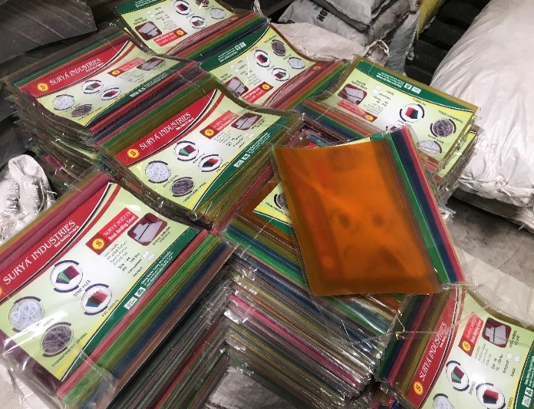

1. **Location of the Unit:**

The Unit is located at Pashamylaram village, Sangareddy District (earlier Medak District). The unit is located in Industrial area and hence availability of experienced and trained personnel is available in the area. Transportation and other logistics are convenient.

1. **Machinery:**

Three machines have been installed in the unit and entrepreneur also engaged 9 employees.

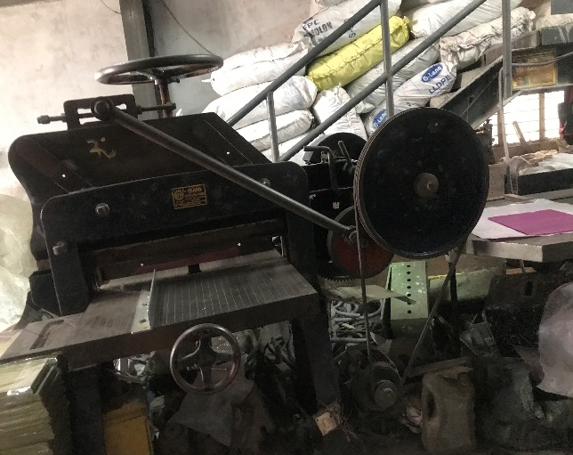 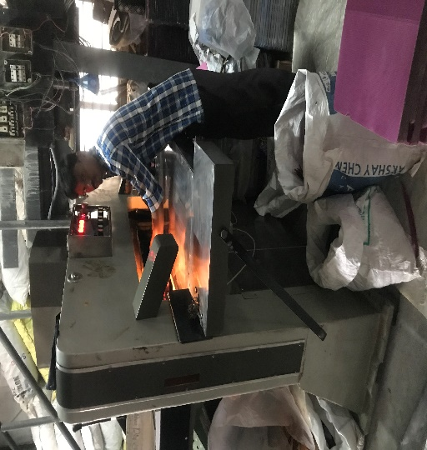

1. **Manufacturing Process:**

The raw material (granules) when heated at 250 degrees temperature takes the liquid form. The liquid then goes through the cooling process and is then transferred to another machinery for preparation of thin films. The films are then moved to cutting machinery and are cut into different sizes. The sheets are then kept for quality checkup and then for dispatch.

* **Managerial Competencies and Family Details and their impact on business:**

The constitution of establishment is sole Proprietorship Mrs. D. Jyothi. She is a graduate and is aware of the manufacturing process. The day to day operations are handled by her husband Mr. D. Sreenivas Rao as he has 25 years of experience in the same line of activity.

* **Inspiration for starting the Enterprise:**

The Entrepreneur worked for a printing and binding firm for about 15 months. Working there for a short period of time, he thought of starting his own manufacturing business of printing. With his own funds on stake he started the business and successfully run for about 10 years. Later he started manufacturing PP sheets and PVC Pipes as there was huge demand for it in the market.

* **First Lender for support and why was it preferred?**

Entrepreneur approached APSFC for the financial support as he was not much aware of the other banks or financing institutions

* **Details of other loans:**

In this case, there are no outside loans as the customer has borne all the expenses on his own.

* **Responses and Support from TIHCL:**

The enterprise needed funds as his EMI was pending which was equivalent to the Investment subsidy receivable amount. Since the entrepreneur could not bring in additional amount for availing TIHCL major services, we considered providing Bridge Finance on sanctioned Investment subsidy from the state government. The investment subsidy was sanctioned in the year 2016 but not yet released by the government.

TIHCL has diagnosed the enterprise and identified following reasons of sickness

* Investment in construction of Shed gone beyond the requirement.
* Effect of increase in GST from 5% to 18%
* Delay in realization of receivables from customers
* Abnormal rate of interest charged by SFC
* High Debt burden of Term Loan EMIs and higher interest rate.
* Non release of sanctioned Incentives and subsidies by the Government for a long time.
* **How TIHCL addressed the concerns:**
* To fund by way of bridge finance against the sanctioned investment subsidy by the state government and to regularize the term loan account.
* The current overdue in T/L is ₹ 10.73 lakhs. With TIHCL funding the Term O/s will be reduced.

**Labor Status: (post TIHCL intervention)**

|  |  |  |
| --- | --- | --- |
| Gender | Skilled | Unskilled |
| Men | 4 | 2 |
| Women | 2 | 1 |
| Total | 6 | 3 |

**Livelihood:** Enterprise created employment to 9 workers at 60% of capacity and may require another 4 to 5 workers during full capacity**.**

* **Confidence on TIHCL:**

After TIHCL intervention, the unit has been performing quiet well as the interest repayment burden is reduced since TIHCL interest charges are less when compared to the Bank.